A Course based Project Report On

CORROSION DETECTION USING MACHINE LEARNING

Submitted in partial fulfilment of requirement for the completion of the
Engineering Chemistry Laboratory course

B. Tech ROBOTICS AND ARTIFICIAL INTELLIGENCE

of VNRVJIETBy

- SIDDARTH RAJARAM (25071A3954)
- SRAVANI MADISETTY (25071A3955)
- PAVANI SRIPATHI (25071A3956)
- SUHAS NANNAPANENI (25071A3957)

Under the Guidance of

Dr. A.SRI CHARITHA

Dr. LIKHA CHANDRAN
Department of Chemistry

2025-2026


VALLURIPALLI NAGESWARARAO
VIGNANA JYOTHI INSTITUTE OF ENGINEERING & TECHNOLOGY (AUTONOMOUS INSTITUTE) NAAC ACCREDITED WITH ‘A++’ GRADE
Vignana Jyothi Nagar, Bachupally, Nizampet (s.o), Hyderabad 500090 Phone no: 040-23042758/59/60, Fax: 040-23042761
Email:postbox@vnrvjiet.ac.in Website: www.vnrvjiet.ac.in

DECLARATION

We hereby declare that this Project Report titled “Corrosion Detection Using Machine Learning” submitted by us of Robotics and Artificial Intelligence in VNR Vignana Jyothi Institute of Engineering and Technology, is a bonafide work undertaken by us and it is not submitted for any other certificate/course or published any time before.

Signature of the Student/Date

1.

2.

3.

4.



VNR VIGNANA JYOTHI INSTITUTE OF ENGINEERING & TECHNOLOGY (AUTONOMOUS INSTITUTE)
NAAC ACCREDITED WITH ‘A++’ GRADE

CERTIFICATE
This is to certify that the project entitled “Corrosion Detection Using Machine Learning” submitted in partial fulfilment for the course of Engineering Chemistry Laboratory being offered for the award of B.Tech (Robotics And Artificial Intelligence) by VNR VJIET is a result of the bonafide work carried out by 25071A3954, 25071A3955 , 25071A3956, 25071A3957 during the year
2025-2026. This has not been submitted for any other certificate or course.

Internal Examiner – 1 Internal Examiner - 2

External Examiner Head, Department of Chemistry

ACKNOWLEDGEMENT

An endeavor over a long period can be successful only with the advice and support of many well-wishers. We take this opportunity to express our gratitude and appreciation to all of them.
We wish to express our profound gratitude to our honourable Principal, and HOD, Robotics And Artificial Intelligence, VNR Vignana Jyothi Institute of Engineering and Technology for their constant and dedicated support towards our career moulding and development.
With a great pleasure we express our gratitude to the internal guides, Dr. A. Sri Charitha, Chemistry, Dr. Likha Chandran, Chemistry, for their timely help, constant guidance, cooperation, support, and encouragement throughout this project as it has urged us to explore many new things.
Finally, we wish to express our deep sense of gratitude and sincere thanks to our parents,friends and all our well-wishers who have technically and non-technically contributed for the successful completion of this course-based project
TABLE OF CONTENTS

S.NO. | CONTENTS | PAGE NO.
1. | ABSTRACT | 1
2. | INTRODUCTION | 2 - 12
3. | LITERATURE REVIEW | 13
4. | METHODOLOGY (FOR EXPERIMENTAL PROJECT)/THEORETICAL ANALYSIS (FOR  THEORETICAL PROJECT) | 14 - 22
5. | RESULTS AND DISCUSSIONS | 23 - 25
6. | CONCLUSIONS | 26
7. | FUTURE SCOPE | 27 - 28
8. | REFERENCES | 29
9. | PLAGIARISM REPORT | 31 - 34

ABSTRACT

Corrosion is a chemical process that gradually damages metal surfaces, often leading to the degradation of the metal and resulting in structural weakness, safety issues, and high maintenance costs. Traditional inspection methods relied on visual observation and physical testing, which are slow and unable to accurately measure the extent of material damage. This project uses machine learning and computer vision to analyze images of metal surfaces like bridges, buildings, and pipelines, and automatically detect corrosion patterns. The model identifies the presence of corrosion, estimates the percentage of damage to the metal, and provides an approximation of the remaining lifespan of the material. This approach provides a fast, non-destructive, and efficient method for monitoring corrosion, enabling better maintenance decisions and enhancing overall safety.

INTRODUCTION

Corrosion:
Corrosion is defined as changes in metal properties due to reactions with a surrounding corrosive environment, which deteriorate the metallic object’s functionality. External or internal corrosion can reduce any steel structure’s lifespan. Many types of defects occur in highway ancillary structures; however, corrosion is the most common. Highway ancillary structures are exposed to weathering effects such as snow and rain, which lead to corrosion over time. Rusting of iron mainly occurs in the environment.
Iron undergoes oxidation-reduction reactions where its oxidation state changes, typically between Fe⁺² and Fe⁺³. Formation reactions involve iron combining with other elements, such as the formation of iron oxides during rust or the production of iron in a blast furnace.

Oxidation : 𝐹 𝑒 ² ⁺ → 𝐹 𝑒 ³ ⁺ + 𝑒 ⁻
Reduction : 𝐹 𝑒 ³ ⁺ + 𝑒 ⁻ → 𝐹 𝑒 ² ⁺
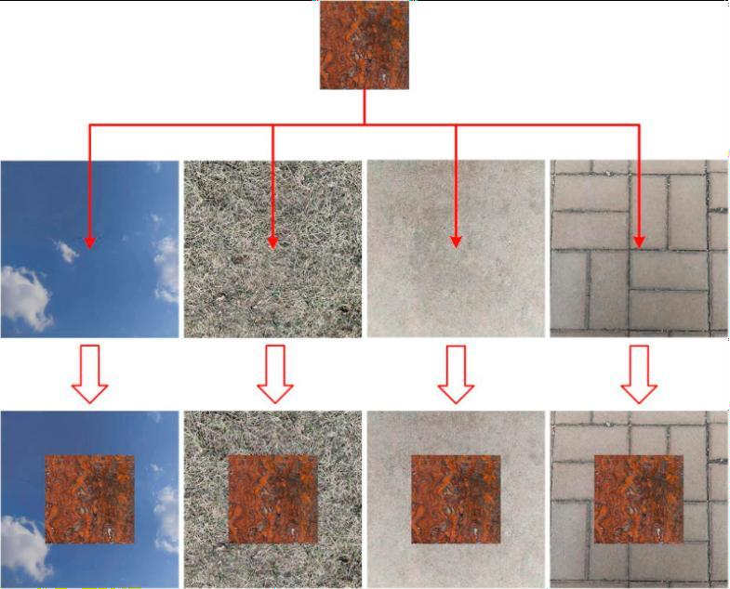

Fig [1.0] Samples of Corrosion

Part of the initial sample image and the corresponding images of the five levels of corrosion are shown in Fig. [1.0]. Through Fig[1.0] sample comparison can be seen in the corrosion process characteristics: level 1 shows a localized un-rusted area—the un-rusted area decreases as time increases; level 2 basically covers the orange-red rust layer with a residual sporadic clean area; level 3 forms a clear and rough texture accompanied by oxide flaking; level 4 has dark corrosion craters and black spots; and level 5 presents a large area of black oxide and metal matrix exposure. There is a significant color gradient (orange-red→dark brown→black) and progressive correlation with structural deterioration (pitting→spalling→exposed substrate) among the levels are shown in Fig[1.1]
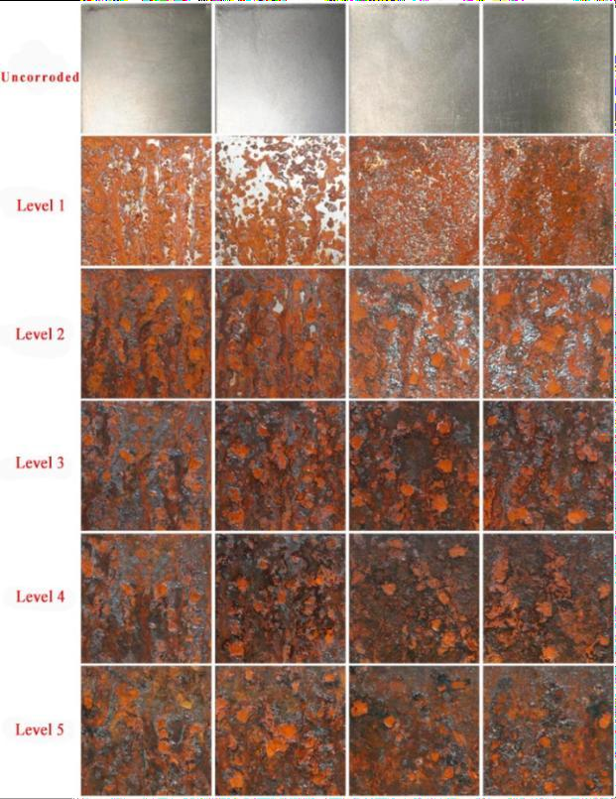
Fig[1.1] Levels of Corrosion

These are the types of corrosion :

Uniform Corrosion
Uniform corrosion is the most common and predictable form of metal degradation. It occurs when the entire metal surface is exposed to a corrosive environment, leading to an even and consistent loss of material.

Fe → Fe²⁺ + 2e⁻. O₂ + 2H₂O + 4e⁻ → 4OH⁻ Formation of Fe₂O₃·xH₂O (rust)
Visual Appearance: Entire surface becomes reddish-brown, Texture becomes rough and flaky, Damage spreads evenly
Relevance to ML: Easiest type to detect because color and texture change very clearly.

Pitting Corrosion
Pitting corrosion is a highly localized form of attack where small, deep holes (pits) form on the metal surface. It is more dangerous than uniform corrosion.
It is often caused by the breakdown of protective films (like oxide layers) due to chloride ions
(Cl⁻).
Visual Appearance: Dark spots, Small holes that grow in the ware surface looks mostly good, but hidden pits cause structural failure.
Relevance to ML: Harder to detect → requires powerful image segmentation or deep learning.

Crevice Corrosion
Occurs in narrow spaces where oxygen circulation is limited. Common around bolts, joints, washers, rivets, or overlapping surfaces.
Visual Appearance: Dark, concentrated rust inside gaps. Corrosion under deposits. Visible staining around joints.
Relevance to ML: Deep models must detect corrosion in partially hidden regions.

Galvanic Corrosion
Occurs when two different metals are in electrical contact in the presence of an electrolyte (water, humidity). Active Metal Oxidses faster to protect Noble Metal.
Visual Appearance: One metal is heavily corroded. The other metal is almost unaffected. Corrosion concentrated near the contact point.
Relevance to ML: The Model must detect mixed textures and color differences around joints.

Stress Corrosion Cracking
A dangerous combination of mechanical stress + corrosive environment that causes cracks to form and grow.
Common in stainless steel, aluminum, and alloys under tensile stress.
Visual Appearance: Thin, branching cracks. Spider-web-like crack pattern. Cracks along grain boundaries.
Relevance to ML: Requires fine crack detection → advanced CV techniques.

Effects and importance of corrosion detection
The effects of corrosion on steel are multifaceted, affecting both the structural integrity and longevity of steel construction.
The importance of identifying corrosion areas and predicting the corrosion depth is emphasized by the need to guarantee safety, optimize maintenance schedules, and extend the useful life of steel structures. By enabling prompt intervention, accurate detection, and prediction can prevent disastrous failures and minimize economic losses.

Consequences of corrosion:

Economic Consequences

- Increased maintenance and repair costs

- Premature failure of structures and machinery

- Frequent replacement of corroded parts

Safety and Structural Failures

- Weakening of load-bearing structures (e.g., bridges, buildings, pipelines, aircraft)

- Leakage of hazardous materials from damaged pipelines or storage tanks

- Increased risk of accidents, explosions, and collapse

Environmental Consequences

- Oil and chemical leaks are polluting soil and water

- Release of toxic metals into ecosystems

- High energy consumption in producing replacements increases the carbon footprint

Performance and Functionality Issues

- Decreased mechanical strength and durability

- Reduced electrical conductivity in electronic equipment

- Blockages in pipelines or valves due to corrosion products

Industrial and Operational Problems

- Shutdowns for maintenance decrease productivity

- Reduced product quality in manufacturing industries

- Contamination in food and pharmaceutical processing equipment

Feature / Aspect | Traditional Corrosion Prevention | Machine Learning-Based Corrosion Prevention
Approach Type | Reactive / Rule-based  Human expertise, empirical formulas, visual inspections  Coatings, cathodic protection, material selection, corrosion allowance, inhibitors  Limited; mostly historical and experience-based  Often detected after visible damage or failure  Can involve human error and delays  Scheduled or reactive maintenance  High in long-term (frequent inspections, replacements) | Predictive / Data-driven  Automated prediction from data patterns (sensor data, environmental factors)  Predictive analytics, anomaly detection, optimization algorithms  Uses large datasets: humidity, temperature, pH, stress levels, electrochemical signals  Detects degradation before failure occurs  High accuracy; improves continuously with new data  Predictive or condition-based maintenance  Reduced lifecycle costs through early detection
Basis of Decision
Making
Common
Techniques
Data Usage
Failure
Detection
Accuracy &
Reliability
Maintenance
Strategy
Cost Impact
Scalability | Difficult to monitor large or complex structures efficiently  Low | Scales easily across many assets with IoT integration  High (real-time monitoring using sensors + AI models)
Automation
Level

Traditional vs Machine Learning approaches in Corrosion prevention

Detection/prediction methods:
There are two main streams of research on corrosion monitoring, those that detect corrosion and those that predict the depth of corrosion.
Corrosion monitoring primarily involves two critical tasks: identifying the area affected by corrosion and determining the extent of material loss. Corrosion area detection refers to locating where corrosion has formed and measuring the size of the affected region. This can be achieved using visual inspections, image processing techniques, ultrasonic testing, infrared thermography, electrochemical sensors, and radiographic methods. These techniques help identify surface discoloration, rust accumulation, and subsurface deterioration, allowing engineers to map corrosion progression over time.
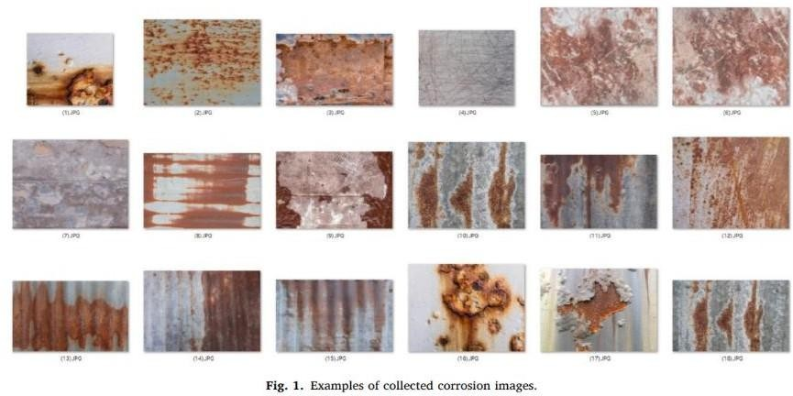
Depth prediction, on the other hand, focuses on estimating how deep the corrosion has penetrated the material. Traditional methods, such as weight loss tests and corrosion rate calculations, provide average depth values, while more advanced non-destructive testing methods like ultrasonic testing, magnetic flux leakage, and eddy current testing can determine detailed depth profiles. Technologies such as laser scanning and 3D reconstruction are also used to create accurate surface models for thickness evaluation.

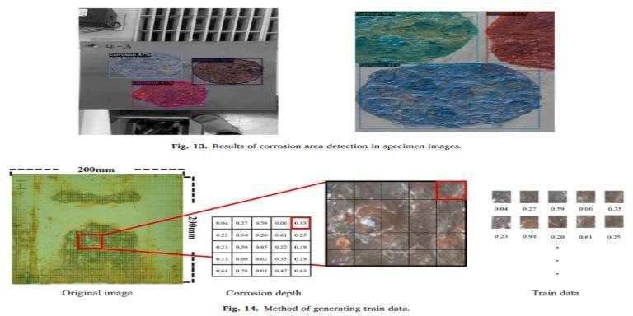
Fig[1.2] Method of generating train data

Role of computer vision in corrosion detection:

- Enables automated, accurate, and real-time corrosion detection without physical contact.
- Analyzes images and videos captured using cameras, drones, and robots.

- Detects corrosion by identifying color changes, texture variations, and shape irregularities.
- Uses techniques such as image segmentation, edge detection, feature extraction, and deep learning.
- Offers greater precision compared to manual visual inspection

- Measures corroded area, severity, and monitors damage progression over time.

- Suitable for large, hazardous, or hard-to-reach structures like pipelines, bridges, ships, and wind turbines.
- CNNs and U-Net models improve corrosion recognition using learned visual patterns.

- Reduces human error and speeds up inspection processes

- Integration with robots and IoT sensors enables continuous and remote monitoring.

- Supports predictive maintenance by giving early warnings before failures.

- Helps improve safety, cost-efficiency, and infrastructure life span.
ML approach:

Machine learning significantly enhances corrosion detection by enabling faster, more accurate, and predictive assessment of material degradation. By learning complex corrosion patterns from sensor data and images, ML models can detect early signs of damage, estimate corrosion severity, and forecast future deterioration more reliably than traditional inspection methods. This not only minimizes human involvement in hazardous environments but also supports condition-based maintenance, reduces unexpected failures, and lowers overall operational costs. Therefore, integrating machine learning into corrosion monitoring systems plays a crucial role in improving safety, extending infrastructure lifespan, and optimizing maintenance strategies for critical industrial assets.

Deep learning in corrosion

Corrosion affects metals under specific environmental conditions: Things like high humidity, wetness, higher temperatures, contact with dangerous chemicals, galvanic reactions, ultraviolet light, and pollution all play a part. These factors cause a quick breakdown in structures. That brings about major economic costs and environmental damage. You can see it clearly in cases of pipeline breakdowns and the general wear on infrastructure. To tackle this problem, one study brings forward a fresh use of deep learning. Deep learning counts as a type of artificial intelligence. It copies the way the human brain picks out patterns. That makes it quite different from the usual manual checks for corrosion. Those old methods tend to drag on slowly. They can be risky too. Plus, they often miss the mark on accuracy. This research will introduce a disruptive method for corrosion detection at an early stage, enabling safety, accuracy, and efficiency improvements through the usage of deep learning's advanced image recognition algorithms.

Models that rely on deep learning and CNNs really matter when it comes to automating the visual inspection of corrosion. That kind of work tends to demand a ton of manual effort right now. These models can pick out patterns in images taken from industrial setups. They do it in a way that mimics how the human brain processes things. Three methods are considered in this work: a CNN designed from scratch, YOLOv8, and Efficient NetB0.

CNNs are typically the foundation of most deep learning models used in image analysis. In this work, CNNs will be utilized to process an enhanced dataset of industrial images that helps in learning and identifying complex features linked to corrosion.

Image Classification Corroded vs Non-Corroded: This is the simplest application, classifying an entire industrial image as corroded or non-corroded. EfficientNetB0 is pre-trained and often used in various applications, like high-accuracy classification, since it scales depth, width, and resolution efficiently.

Object Detection-YOLOv8: This method goes further by not just classifying an image, but also marking specific areas with a bounding box where corrosion is present. Among the alternative solutions, the YOLOv8 model stands out in its speed and accuracy of location and identification of corrosion in real-time industrial images. It seeks the detection of all types of corrosion.

Segmentation comes from models like Mask R-CNN. These models offer great detail by creating a pixel-level mask of the corroded area instead of just a bounding box. This can be used in later steps for accurate damage mapping.

Severity-classification models can further categorize the identified corrosion into severity or stages, such as light, moderate, and severe. This also provides maintenance teams with vital information to prioritize repairs accordingly.

Regression Models for Corrosion Rate: Advanced models, which are usually based on historical data and environmental factors such as temperature and humidity, can use regression methods to predict future corrosion rates or the remaining useful life of an asset. This approach progresses from reactive detection to proactive, predictive maintenance.

Future directions for Artificial Intelligence in Corrosion detection
Predictive Corrosion Modeling: Rather than just detecting it, AI will predict the corrosion progression based on historical data, environmental conditions, and material properties. It will make use of techniques such as multivariate regression, time-series forecasting, and reinforcement learning to determine when and where corrosion is most likely to occur.
- Integration of Digital Twin: AI-driven corrosion models will be integrated into the virtual

replicas of physical assets, also known as digital twins. It enables the simulation of real-time corrosion behavior for changing conditions, thus facilitating wiser maintenance planning and risk assessments.

- Edge AI and Autonomous Inspection: Lightweight AI models will be deployed on drones, robots, and smart cameras for real-time on-site corrosion monitoring. It reduces the need for manual inspection in hazardous or remote environments.

The introduction presents the chemical background and the need for the detection of corrosion. The review of the literature summarizes available research. Methodology explains both the theoretical framework and the proposed AI model. Results and discussions present observations. The report identifies future scope for improving corrosion prediction.

LITERATURE REVIEW

Amrita Das reviewed the state-of-the-art techniques for corrosion detection in steel structures, focusing on image-based and deep learning approaches. She developed and trained convolutional neural networks (CNNs) and semantic segmentation models to identify corroded regions in images of steel surfaces.[1]

Heng Piao contributed to the article by reviewing and supporting the implementation of the improved YOLOv8 model for corrosion-grade recognition, with a focus on system integration and real-time application. [2]

Nhat-Duc Hoang reviewed and contributed to the integration of image processing, texture analysis, and metaheuristic-optimized machine learning for detecting pipe corrosion in the article.[3]

Dayeon Jeong contributed to the article by reviewing and supporting the development of the machine learning framework for corrosion detection and depth prediction, with a focus on data processing and model evaluation. He reviewed the image dataset used for training the Mask R- CNN model, ensuring that corrosion areas were accurately labeled.[4]

Yuan Yao, Yang Yang, Yanpeng Wang, and Xuefeng Zhao reviewed how corrosion develops in difficult environmental conditions and showed that early identification is important for reducing structural damage and avoiding costly maintenance issues.[5]

Zahra Ameli, Shabnam Jafarpoor Nesheli, and Eric N. Landis reviewed modern deep learning methods for corrosion detection, showing that advanced models can automatically recognize and locate damaged areas with better accuracy.[6]

Mehwash Farooqui et al. reviewed and developed a deep learning–based approach for industrial corrosion detection using image data. Their work evaluated convolutional neural networks (CNNs) along with pretrained models such as YOLOv8 and EfficientNetB0 to improve corrosion detection accuracy across industrial environments. The study demonstrated that deep learning models can reliably identify corrosion regions from images with high accuracy, supporting automated and non-destructive inspection in industrial applications.[7]

Azhar M. Memon, Imil Hamda Imran, and Luai M. Alhems reviewed and developed a neural network–based corrosion modeling approach for stainless steel 316L pipelines, focusing on predicting wall thickness loss under corrosive environments. Their study used artificial neural networks trained on electric field mapping data, including voltage, current, and temperature measurements, to accurately model corrosion behavior. The results showed that neural networks can effectively predict corrosion progression and remaining wall thickness, enabling proactive maintenance and improved asset integrity management.[8]

THEORETICAL ANALYSIS

Introduction

Corrosion is a natural but harmful process that slowly damages metal surfaces. It weakens pipelines, ships, bridges, electrical equipment, and many industrial systems. Across all industries, corrosion leads to huge financial losses, reduced safety, and early failure of structures. Traditionally, corrosion monitoring is done manually, which is slow, risky, and depends on the skill of the inspector.
With the rise of artificial intelligence (AI), machine learning (ML), deep learning (DL), and image processing, researchers have begun developing automated corrosion-detection systems. These systems analyse images of metal surfaces and identify corrosion, classify severity, and even predict corrosion depth.
All the research papers explore different approaches—Mask R-CNN, CNNs, ResNet, YOLOv8, UNet, SVM, texture analysis, and unsupervised learning. Together, these studies show how AI can transform corrosion detection into a fast, accurate, and reliable process.
Mask R-CNN - Mask Regional Convolutional Neural Network CNN - Convolutional Neural Network
ResNet - Residual Network

YOLOv8 - You Only Look Once – Version 8 UNet - U-shaped architecture of the network SVM - Support Vector Machine

- Need for Automated Corrosion Detection

Corrosion is a major threat to structural health. Manual inspection suffers from limitations:

- It is time-consuming and labour-intensive, Corrosion Assessment Using Image-based

- Many corroded areas are hard to reach, leading to missed defects. Autonomous
Image‑Based Corrosion

- Human judgment is subjective and inconsistent.

Because of these limitations, researchers have focused on developing automated models that can detect corrosion from images with high accuracy.
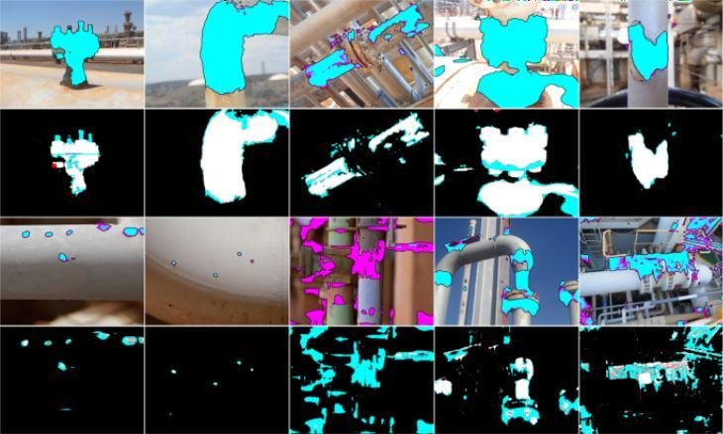
Fig[2.1] Images based on computer vision based defect detection

Review of Approaches in the Research Papers

All the research papers use different algorithms, but all aim to improve the speed and accuracy of corrosion detection. The analysis below combines all their methods and findings in a unified way.

Deep Learning-Based Corrosion Detection
    - CNN Models and Transfer Learning

Several papers showed that Convolutional Neural Networks (CNNs) can extract powerful features from images.

      - ResNet-based models classify corrosion severity with high accuracy (up to human level)- Corrosion Assessment Using Image-based.
      - CNNs trained on pipe and industrial images achieve 98–100% classification accuracy in some studies-A Deep Learning Approach to Industrial-based.
      - CNNs work well because they learn rust-related patterns like colour, texture, and surface roughness.

Key Points:

- CNNs automatically learn important corrosion features.

- Pre-trained networks like ResNet, VGG, Efficient Net perform better due to strong feature extraction.
- CNN-based systems reduce inspection time and increase consistency.

    - Mask R-CNN for Detection and Depth Prediction

The paper Corrosion Area Detection and Depth Prediction Mask takes R- CNN + depth regression takes corrosion detection a step further by not only identifying corroded regions but also estimating corrosion depth from images.
      - 35,753 images were used, making the system very robust.

      - Depth prediction helps engineers decide how urgent maintenance is.

      - Colour-map variations were used to make depth prediction reliable across different lighting environments.

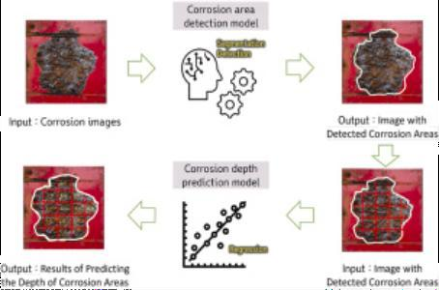
Fig[2.2] Workflow for Corrosion Detection and Depth Estimation

Key Points:

- Mask R-CNN detects corrosion boundaries precisely.

- Depth prediction makes inspection more quantitative.

- Useful for ships, which face heavy corrosion in seawater.

    - UNet and Encoder–Decoder Models

The Autonomous Image-based Corrosion paper studied UNet, ResNet34-UNet, DenseNet- UNet, and EfficientNet-based UNet for pixel-level segmentation of corroded areas
Findings included:

      - EfficientNetB7 performed poorly on small datasets.

      - ResNet34-UNet gave the most stable pixel-level predictions with only 2.98% false positives.
      - UNet-based models work well when corrosion patterns are irregular and complex.

Key Points:

- UNet handles irregular corrosion shapes better than bounding-box models.

- Transfer learning improves performance when datasets are small.

- Pixel-level detection enables fine-detail corrosion mapping.

    - YOLOv8-Based Corrosion Detection

The YOLOv8 study proposed an improved version by adding:

      - Attention mechanisms

      - Mixed-sample data augmentation

      - Cosine annealing for learning rate adjustment

This model achieved 96.3% mAP and 93.6% F1-score, outperforming Faster R-CNN and other models

Key Points:

- YOLOv8 enables real-time corrosion detection.

- Attention improves the ability to highlight important rust features.

- Data augmentation helps the model generalize better to noise and lighting changes.

Machine Learning and Traditional Image Processing

Not all studies used deep learning. Some used classical ML and image-processing:

    - Texture Analysis + SVM:

      - Colour statistics, Grey-Level Co-Occurrence Matrix (GLCM), Run-Length Matrix

Then, using Image-Based Corrosion Detection, it used a Support Vector Machine (SVM) optimized by a metaheuristic algorithm (DFP) to classify corrosion vs. non-corrosion, achieving 92.81% accuracy.

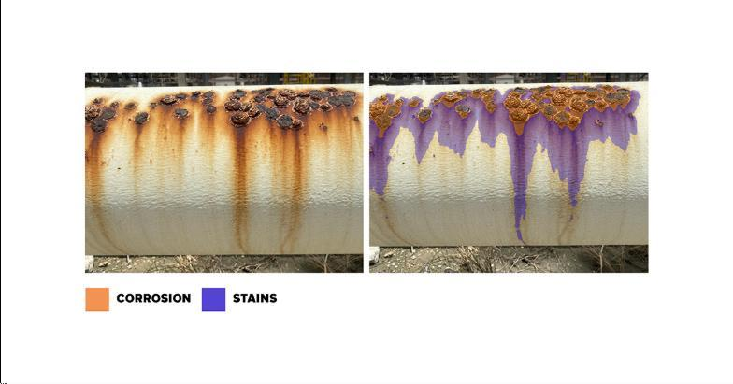
Fig[2.3] Identification of Corrosion and Stains

- Texture features capture corrosion patterns in a simple way.

- SVM works well for binary classification.

- Lower cost and less computational power than deep learning.

    - Unsupervised Learning for Corrosion Staging

This paper used microscopy images to compute porosity and deposit thickness, then clustered them to determine corrosion stages. It achieved ~73% accuracy in staging under-deposit corrosion.

Key Points:

- No labelled data is required.

- Useful for early-stage corrosion in microscopes.

- Helps industries analyse corrosion where human staging is subjective.

    - ANN-Based Corrosion Modelling for Stainless Steel

This paper used Artificial Neural Networks (ANNs) to predict wall-thickness loss in SS316L
elbows using electric field mapping data. Errors were extremely low (<1%).

Key Points:

- ANN models can predict corrosion behaviour in pipelines.

- Very useful for maintenance scheduling and provides real-time wall-thickness information.

Combined Insights from All Papers

From all studies, several shared conclusions emerge.

  - AI Greatly Improves Corrosion Detection

Across all papers, AI techniques consistently improved:

- Accuracy

- Speed

- Reliability

- Cost-effectiveness

Most DL models achieved 90–100% accuracy, making them more dependable than human inspection.

  - Image Data Is Extremely Valuable

All systems relied heavily on image datasets. These images highlight:

- Rust colour and Texture roughness

- Surface irregularities and Dirt or foreign deposits

Larger datasets (e.g., 35,753 images in the Mask R-CNN study) produced more robust models.

Different Algorithms Suit Different Conditions

Application | Best Performing Approach | Reason
Pixel-level mapping | UNet-based models | Precise segmentation
Real-time detection | YOLOv8 | Fast and efficient
Depth prediction | Mask R-CNN + regression | Strong region extraction
Pipe surface detection | SVM + texture | Lightweight method
Under-Deposit corrosion | Unsupervised ML | No labels needed
Pipeline wall thickness | ANN | Learns from sensor data

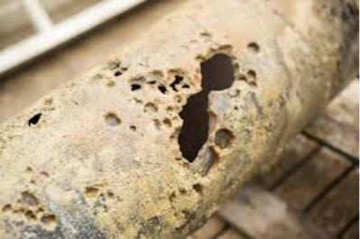
Fig[2.4]Corrosion-Induced Structural Failure in Pipelines

  - Lighting and Environment Affect Performance

Several studies noted that image colour and lighting strongly impact model accuracy. Solutions included:
- Data augmentation
- Colour-space conversion (HSI, HSV)
- Attention mechanisms
- Robust pre-trained weights

Advantages of Using AI for Corrosion Detection

- Higher Accuracy- Many models achieved >95% accuracy, reducing the chances of missing dangerous corrosion spots.

- Faster and Safer Inspections- AI can process thousands of images quickly, reducing the need for risky manual inspections.

Objective Decisions- AI is consistent and not affected by human fatigue or subjectivity.

Limitations and Challenges

- Models need large datasets for best performance.

- Lighting variations make the rust colour inconsistent.

- Some models fail on rare corrosion types.

- Unsupervised methods have lower accuracy (~73%).

Conclusion

All research papers clearly show that AI, deep learning, machine vision, and ML are transforming corrosion detection into a fast, reliable, and automated process. Models like Mask R-CNN, UNet, ResNet, YOLOv8, EfficientNet, SVM, and ANNs each contribute unique strengths.

Overall, AI-based corrosion detection promises:

- Improved safety

- Reduced maintenance costs

- Longer lifespan of structures

- Accurate severity classification

- Real-time monitoring

RESULTS AND DISCUSSIONS

The combined results from the corrosion detection and simulation research reveal that deep learning and machine learning have taken the automation and accuracy of corrosion assessment to a whole new level. In all the different studies, deep learning models are more accurate, reliable, and capable of adapting to real industrial settings than traditional methods.
Deep learning classification models like ResNet50 and VGG16 demonstrated different degrees of performance. Supported by high precision and recall metrics, ResNet50 was able to achieve a very good 76.7% accuracy, thus proving its ability to differentiate between various levels of corrosion with a fair amount of consistency. On the other hand, VGG16 only resulted in 67% accuracy, thereby pointing to the shortcomings of its feature extractor in terms of hierarchical deep features necessary for accurate corrosion identification. This comparison reinforces the notion that it is the latest models with greater depth and residual connections that are better equipped to handle complex corrosion patterns.
The utilization of cutting-edge models in industrial corrosion detection setups has led to phenomenal accomplishments. Both EfficientNetB0 and a custom CNN were able to attain 100% accuracy, precision, recall, and F1-score, which is a strong indication of their extraordinary capabilities when fed with well-augmented datasets. In order for a detector to be able to work in real-time, YOLOv8 is a good candidate since it came up with 95% accuracy with 100% precision, thus it can be used for quick inspections when both speed and reliability are of equal importance. Therefore, these findings corroborate that deep learning is not only very efficient in static image analysis but can also be employed in real-time industrial monitoring.
Moreover, segmentation models like Mask R-CNN were capable of providing accurate pixel- level identification with precision and recall figures close to 86% and 84%, respectively, for detailed corrosion evaluation. In addition to detection, the model's ability to approximate corrosion depth provides an additional layer of structural inspection, thus allowing for more accurate material degradation analytics. Such a degree of granularity becomes quite vital in those sectors wherein the safety of maintenance operations largely depends on the exact location and depth of corrosion.
Additional improvements were illustrated with the modified YOLOv8 versions that contained

mechanisms for focusing and refining features. The enhancements here resulted in the model being able to accurately determine the detailed grades of corrosion with an 11% rise in precision, recall, and F1-score and a 6% increase in mAP, thereby greatly extending their potential use in power substations and the rest of the industry, where repair prioritization is fraught with the accuracy of severity grading. In this line of work, being able to correctly grade the severity of a problem means knowing at what point it gets fixed.
On the other hand, traditional image processing approaches like HOG + SVM were good at detecting corrosion on simple surfaces but could not deal with the changes in lighting, texture, and background that were present in the cases tested. These results reaffirm the notion that while there is still a place for classical methods, they are less capable when it comes to dealing with the variability found in real-world industrial environments.
In addition to detection, neural network-based predictive models showed great ability in predicting the future of stainless steel corrosion. They were able to precisely anticipate the changes in the depth of the pits, the rate at which the corrosion will progress, and the behavior of the passivation, thus demonstrating the potential of AI in not only identifying corrosion but also in predicting its long-term evolution.
Moreover, unsupervised learning methods did well in situations where there were very few labeled data. By joining autoencoders and clustering methods, the created groups of corrosion images could be understood as different severities, which in turn showed how helpful these techniques are for the initial phase of dataset creation and for automatic staging of corrosion in unlabeled environments.
The use of AI in conjunction with unmanned aerial vehicles (UAVs) has led to the improvement of corrosion inspection capabilities. Imaging systems installed on drones and powered by deep learning have inspected structures such as pipelines, roofs, and storage tanks not only easily and safely but also doable on a large scale. By using this method, the time spent on manual inspection has been cut down quite a bit, and the safety risks that come with inspections carried out by humans have been minimized as well.
In summary, the joint outcomes of the work show that deep learning and machine learning are capable of delivering solutions that are not only extremely accurate but also scalable and practical in areas such as corrosion detection, classification, segmentation, and prediction. Although there are still some issues that need to be resolved before the methods can be used in
the real world, e.g., dataset imbalance, environmental variability, and generalization across diverse industrial surfaces, the consistent good performance of the models is an indicator that AI-enabled corrosion assessment is fast becoming a mandatory tool of modern infrastructure maintenance. These technological breakthroughs extend a wide range of safety, cost-saving, predictive maintenance planning, and operational reliability benefits across various sectors.

CONCLUSION

Corrosion is a huge problem that begins with fundamental electrochemical reactions but ultimately leads to large-scale structural, economic, and safety challenges. Through this project, we explored how corrosion leaves visual marks that can be identified and interpreted using modern machine learning and computer vision techniques. By analyzing patterns such as color variations, surface texture changes, pitting, and crack formation, AI models can identify corrosion with a level of consistency and speed far beyond human inspection.
Our theoretical pipeline demonstrates how a single image can be processed, enhanced, and passed to learning models that estimate corrosion presence, classify the severity, calculate the percentage of damaged area, and even predict material remaining life. This approach represents a big leap from reactive manual monitoring to proactive intelligence-driven assessment.
While this work is theoretical, the results discussed here have strong promise for real-world applications: industrial inspection, infrastructure monitoring, and automated maintenance systems. Chemistry knowledge combined with machine learning provides an interdisciplinary framework that powerfully solves corrosion-related challenges.
This project thus covers the fact that early detection and prediction of corrosion using AI in such a framework are not only feasible but highly essential to enhance safety, cut costs, and prolong the life of critical structures. While corrosion may be inevitable, with intelligent systems, its consequences no longer need to be.

FUTURE SCOPE

The nanotechnology-based corrosion detection device offers enormous scope for future research, technological upgrading, and industrial scaling. Since nanoscience will continue to evolve further, successive generations of this device will be able to adopt highly advanced nanostructured sensors like graphene-based, metal oxide, and carbon nanotube sensors that can further enhance sensitivity, selectivity, and response time. This will lead to very early detection of corrosion at the microscopic level itself, preventing serious structural damage and material degradation.
The system can also be integrated with advanced artificial intelligence and deep learning algorithms in the future for automatic identification, classification, and depth prediction of corrosion by using image processing techniques. Such intelligent automation will ensure accurate interpretation of corrosion data, eliminate subjective errors, and reduce the need for skilled manual inspection. The application of predictive analytics can give a better estimation of the remaining service life of materials and structures.
This device can also be enhanced by incorporating the IoT, cloud computing, and wireless sensor networks to offer real-time corrosion monitoring and remote access to data. Therefore, corrosion conditions can be tracked continuously in critical infrastructures like pipelines, offshore platforms, bridges, ships, storage tanks, chemical plants, and nuclear power facilities. Maintenance personnel can be informed instantly through smart dashboards integrated with mobile applications regarding alerts and condition-based maintenance recommendations.
The systems of the future may include autonomous drone- and robotic-based inspection systems with nano sensors and high-resolution cameras. They could be able to monitor corrosion in hazardous, high-temperature, underwater, and inaccessible regions, improving worker safety and the efficiency of inspections. Nanotechnology, combined with robotics and artificial intelligence, is able to transform a traditional system of corrosion inspection into a fully automated smart monitoring system.
Further research can be carried out on the miniaturization of devices, optimization of cost, and improvement in energy efficiency by using low-power electronics and renewable energy sources like solar-powered sensor units. This makes the device more portable and sustainable; it can also be used for long-term continuous monitoring. Environmentally friendly

nanomaterials and green synthesis routes will also contribute to environmentally sustainable solutions for corrosion monitoring.
By integrating nanotechnology with smart sensing, real-time data analytics, AI-based prediction, and wireless communication in corrosion detection, this system holds great importance for predictive maintenance, the prevention of accidents, the reduction of economic losses due to corrosion, and the enhancement of public and industrial safety. This, therefore, is a project with great future potential for commercialization, interdisciplinary research, and large-scale deployment in infrastructure, energy, transportation, and chemical industries.

REFERENCES

- : Das, Amrita,Dorafshan, Sattar,Kaabouch, Naima,"Autonomous Image-Based Corrosion Detection in Steel Structures Using Deep Learning",Sensors,Volume-24,Issue-11,Year- 2024,DOI:-10.3390/s24113630.
- : Chen, Hao,Cao, Ying,Cao, Shengxian,Piao, Heng,"A Study of Corrosion-Grade Recognition on Metal Surfaces Based on Improved YOLOv8 Model",Sensors,Volume- 25,Issue-8,Year-2025,DOI:-10.3390/s25082630.
- : Hoang, Nhat Duc,Tran, Van Duc,"Image Processing-Based Detection of Pipe Corrosion Using Texture Analysis and Metaheuristic-Optimized Machine Learning Approach",Computational Intelligence and Neuroscience,Volume-2019,Year-2019,DOI:- 10.1155/2019/8097213.
- : Son, Eun Young,Jeong, Dayeon,Oh, Min Jae,"Corrosion area detection and depth prediction using machine learning",International Journal of Naval Architecture and Ocean Engineering,Volume-16,Year-2024,DOI:-10.1016/j.ijnaoe.2024.100617.
- : Harshavardhan, Bagathi,Alapati, Mallika,Rahul, Alapati,Sathwik, Lemuel,"Corrosion Assessment Using Image Based Deep Learning Models",*Elsevier B.V.*,Year -2025,DOI:-10.1016/j.prostr.2025.07.076.
- : RajKumar, Ashwin,Paluru, Naveen,Mathew, Raji Susan,Shenai, Prathamesh,Abdeen, Dana,Laycock, Nicholas,Yalavarthy, Phaneendra K.,"Unsupervised machine learning for automated corrosion staging using optical microscopy images",npj Materials Degradation,Volume-9,Issue- 1,Year -2025,DOI:-10.1038/s41529-025-00635-1.
- : Memon, Azhar M. ,Imran, Imil Hamda, Alhems, Luai M. , "Neural network based corrosion modeling of Stainless Steel 316L elbow using electric field mapping data",Scientific Reports,Volume- 13, Issue- 1,Year -2023,DOI:-10.1038/s41598-023-40083- y.
- : Farooqui, Mehwash,Rahman, Atta,Alsuliman, Latifa,Alsaif, Zainab,Albaik, Fatimah,Alshammari, Cadi,Sharaf, Razan,Olatunji, Sunday,Althubaiti, Sara Waslallah,Gull, Hina,"A Deep Learning Approach to Industrial Corrosion Detection",Computers, Materials and Continua,Volume- 81, Issue- 2,Year -2024,DOI:-10.32604/cmc.2024.055262.

PLAGIARISM REPORT
Abstract Corrosion is a chemical process that gradually damages metal surfaces, often leading to the degradation of the metal and resulting in structural weakness, safety issues, and high maintenance costs. Traditional inspection methods relied on visual observation and physical testing, which are slow and unable to accurately measure the extent of material damage. This project uses machine learning and computer vision to analyze images of metal surfaces like bridges, buildings, and pipelines, and automatically detect corrosion patterns. The model identifies the presence of corrosion, estimates the percentage of damage to the metal, and provides an approximation of the remaining lifespan of the material. This approach provides a fast, non-destructive, and... (only first 800 chars shown)
 | Analysis complete. Our feedback is listed below in printable form. Some of the items have been truncated or removed to provide better print compatibility.
Plagiarism Detection
Original Work
Originality: 99%
 Congratulations! This paper seems to be entirely original.
The following web pages may contain content matching this document:
http://journal.frontiersin.org/Journal/10.3389/...
https://www.studymode.com/essays/Types-Of-Corro...
https://www.termpaperwarehouse.com/essay-on/Cas...
https://www.termpaperwarehouse.com/essay-on/Isi...
http://link.springer.com/article/10.1186/s13561...
https://arxiv.org/abs/1607.06595
https://arxiv.org/abs/1709.05943
View Matching Text
Click the button above to see which portions of your text match which sources. This is a premium-only feature.
More info on our originality scoring process.
Word Choice
Usage of Bad Phrases
Bad Phrase Score: 0.94 (lower is better)
The Bad Phrase Score is based on the quality and quantity of trite or inappropriate words, phrases, egregious misspellings, and cliches found in your paper. You did equal or better than 98% of the people in your grade.

Terrific work! Based on your phrases, you scored much higher than average.
Style
Usage of Transitional Phrases
Transitional Words Score: 64
This score is based on quality of transitional phrases used within your paper. You did equal or better than 50% of the people in your grade.

Your usage of transitional phrases may be within an acceptable range, but I know you can do better. Please read the information below and apply the advice to your writing.
One sign of an excellent writer is the use of transitional phrases (e.g. therefore, consequently, furthermore). Transitional words and phrases contribute to the cohesiveness of a text and allow the sentences to flow smoothly. Without transitional phrases, a text will often seem disorganized and will most likely be difficult to understand. When these special words are used, they provide organization within a text and lead to greater understanding and enjoyment on the part of the reader.
The following transitional phrases were found in your document:
and, since, usually, instead, thus, however, therefore, rather, in addition, although, in summary, accordingly, in turn, moreover, on the other hand

Consider using additional transitions where appropriate:
• consequently
• nevertheless
• notwithstanding
• conversely
• ordinarily
These words and phrases fall under a few grammatical categories:
• Conjunctions: but, provided, and, although
• Prepositional phrases: in addition to, in conclusion
• Adverbs: also, however, nevertheless
Consider this example:
I lost my money; therefore, I could not buy a ticket.

The word 'therefore' contributes to greater unity or cohesion between sentences and allows the text to flow more smoothly.
Style
Sentence Length Info
Total Sentences: 372
Avg. Length: 13.0 words
Short Sentences (< 17 words): 255 (69%)
Long Sentences (> 35 words): 15 (4%)
Sentence Variation: 11.0 words (std deviation)
There is no 'perfect' sentence length, but your average sentence length is within an acceptable range.
Line chart of the length of each sentence (first 50 sentences). A jagged chart indicates variation.
Helpful Resources:
- Effective Use of Sentence Length
Vocabulary Words
Usage of Academic Vocabulary
Vocabulary Score: 387.04
This score is based on the quantity and quality of scholarly vocab words found in the text. You did equal or better than 94% of the people in your grade.


Vocabulary Word Count: 372
Percentage of Vocab Words: 10.2%
Vocab Words in this Paper (top 20):
galvanic, degradation, ancillary, localized, multifaceted, empirical, inhibitors, predictive, integrating, facilitating, autonomous, theoretical, framework, implementation, subjectivity, hierarchical, utilization, augmented, corroborate, mechanisms

Your knowledge of refined language is magnificent. Visit our Vocab Builder to expand your internal dictionary even more.

Tips
Whether you are writing for a school assignment or professionally, it is imperative that you have a vocabulary that will provide for clear communication of your ideas and thoughts. You need to know the type and level of your audience and adjust your vocabulary accordingly. It is worthwhile to constantly work at improving your knowledge of words. To help with this task, please consider using our Vocabulary Builder to improve your comprehension and usage of words.

